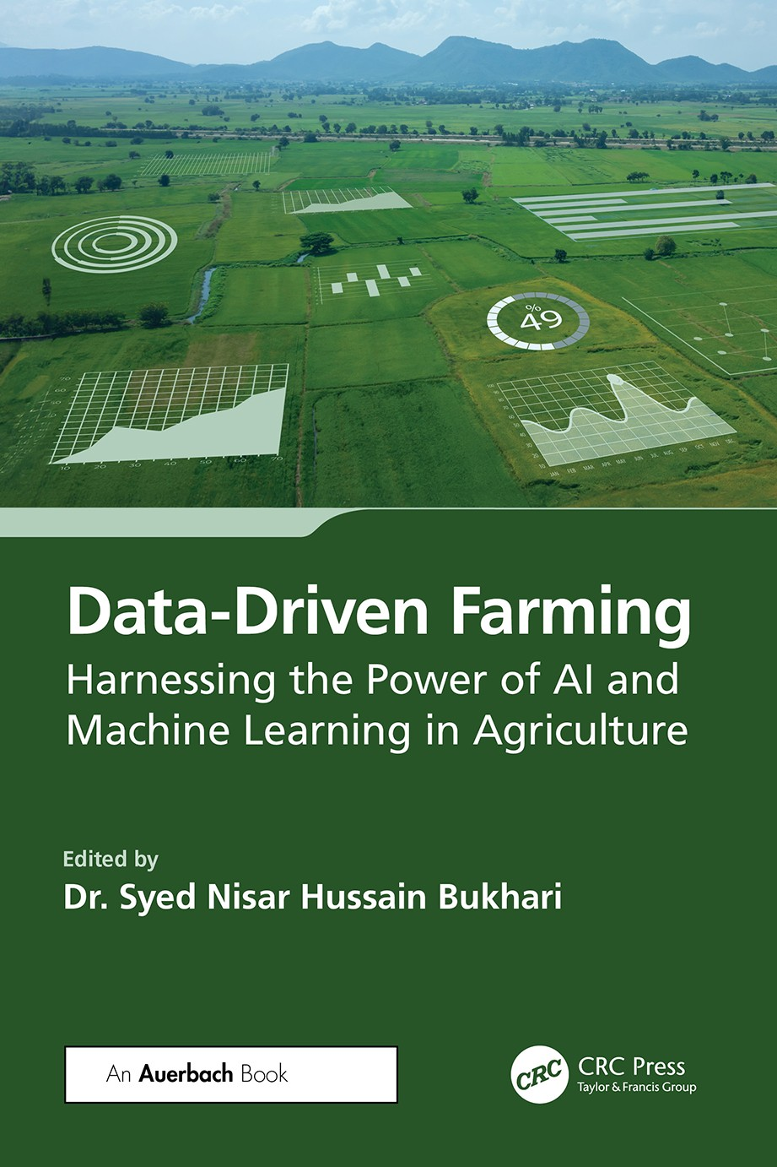

Data-Driven Farming

In the dynamic realm of agriculture, artificial intelligence (AI) and machine learning (ML) emerge as catalysts for unprecedented transformation and growth. The emergence of big data, Internet of Things (IoT) sensors, and advanced analytics has opened up new possibilities for farmers to col- lect and analyze data in real-time, make informed decisions, and increase efficiency. AI and ML are key enablers of data-driven farming, allowing farmers to use algorithms and predictive models to gain insights into crop health, soil quality, weather patterns, and more. Agriculture is an indus- try that is deeply rooted in tradition, but the landscape is rapidly changing with the emergence of new technologies.
Data-Driven Farming: Harnessing the Power of AI and Machine Learn- ing in Agriculture is a comprehensive guide that explores how the latest advances in technology can help farmers make better decisions and maxi- mize yields. It offers a detailed overview of the intersection of data, AI, and ML in agriculture and offers real-world examples and case studies that dem- onstrate how these tools can help farmers improve efficiency, reduce waste, and increase profitability. Exploring how AI and ML can be used to achieve sustainable and profitable farming practices, the book provides an introduc- tion to the basics of data-driven farming, including an overview of the key concepts, tools, and technologies. It also discusses the challenges and oppor- tunities facing farmers in today’s data-driven landscape. Covering such top- ics as crop monitoring, weather forecasting, pest management, and soil health management, the book focuses on analyzing data, predicting out- comes, and optimizing decision-making in a range of agricultural contexts.



Data-Driven Farming
Harnessing the Power of AI and
Machine Learning in Agriculture

Edited by
Dr. Syed Nisar Hussain Bukhari





First edition published 2024
2385 NW Executive Center Drive, Suite 320, Boca Raton FL 33431
and by CRC Press
4 Park Square, Milton Park, Abingdon, Oxon, OX14 4RN
CRC Press is an imprint of Taylor & Francis Group, LLC
© 2024 Taylor & Francis Group, LLC
Reasonable efforts have been made to publish reliable data and information, but the author and publisher cannot assume responsibility for the validity of all materials or the consequences of their use. The authors and publishers have attempted to trace the copyright holders of all material reproduced in this publication and apologize to copyright holders if permission to publish in this form has not been obtained. If any copyright material has not been acknowledged please write and let us know so we may rectify in any future reprint.
Except as permitted under U.S. Copyright Law, no part of this book may be reprinted, reproduced, transmitted, or utilized in any form by any electronic, mechanical, or other means, now known or hereafter invented, including photocopying, microfilming, and recording, or in any information storage or retrieval system, without written permission from the publishers.
For permission to photocopy or use material electronically from this work, access www. copyright.com or contact the Copyright Clearance Center, Inc. (CCC), 222 Rosewood Drive, Danvers, MA 01923, 978-750-8400. For works that are not available on CCC please contact mpkbookspermissions@tandf.co.uk
Trademark notice: Product or corporate names may be trademarks or registered trademarks and are used only for identification and explanation without intent to infringe.
ISBN: 978-1-032-61892-0 (hbk)
ISBN: 978-1-032-77872-3 (pbk)
ISBN: 978-1-003-48517-9 (ebk)
DOI: 10.1201/9781003485179
Typeset in Minion
by SPi Technologies India Pvt Ltd (Straive)

This book is dedicated to my loving father, the late Syed Gulam Mohi ud Din Bukhari (Aba Jan) and my loving and caring mother, the late Zareefa Syedah, whose wisdom and love continue to inspire my quest for knowledge and innovation.



Contents

Editor Biography x
Contributors xii
Preface xv
Acknowledgments xvii
Chapter 1 Leveraging IoT for Precision Health Monitoring in Livestock with Artificial Intelligence 1
Devinder Kaur and Amandeep Kaur Virk
Chapter 2 Significance of Machine Learning in Apple Disease Detection and Implications 19
Saimul Bashir, Syed Nisar Hussain Bukhari, Faisal Firdous, and Gursimran Jeet Kour
Chapter 3 Intelligent Inputs Revolutionizing Agriculture:
An Analytical Study 42
Nelofar Ara, Sani Mustapha Kura, VK Aswathy, and Mohammad Amin Wani
Chapter 4 Case Studies on the Initiatives and Success Stories of
Edge AI Systems for Agriculture 56
Thamizhiniyan Natarajan and Shanmugavadivu Pichai
Chapter 5 Crop Recommender: Machine Learning–Based Computational Method to Recommend the Best Crop
Using Soil and Environmental Features 81
Syed Nisar Hussain Bukhari, Jewiara Khursheed Wani, Ummer Iqbal, and Muneer Ahmad Dar
Chapter 6 A Perusal of Machine-Learning Algorithms in
Crop-Yield Predictions 101
Anshika Gupta, Mohit Soni, and Kalpana Katiyar
vii
viii • Contents
Chapter 7 Harvesting Intelligence: AI and ML Revolutionizing Agriculture 126
Arya Kumari, Muhammad Najeeb Khan, and Amit Kumar Sinha
Chapter 8 Using Deep Learning to Detect Apple Leaf Disease 142
Syed Nisar Hussain Bukhari, Rukaya Manzoor, Ummer Iqbal, and Muneer Ahmad Dar
Chapter 9 Agricultural Crop-Yield Prediction: Comparative
Analysis Using Machine Learning Models 158
Kukatlapalli Pradeep Kumar, S. Babu Kumar, Amarthya Dutta Gupta, Kevin Johnson, and Meghan Mary Michael
Chapter 10 Fundamentals of AI and Machine Learning with
Specific Examples of Application in Agriculture 178
Manoj Kumar Mahto, P. Laxmikanth, and V.S.S.P.L.N. Balaji Lanka
Chapter 11 Farming Futures: Leveraging Machine Language for Potato Leaf Disease Forecasting and
Yield Optimization 200
A. Vijayalakshmi, A. Nidin, and Deepthi Das
Chapter 12 Classification of Farms for Recommendation of Rice Cultivation Using Naive Bayes and SVM:
A Case Study 216
Qurat-ul-ain, Uzma Hameed, and Hamira Mehraj
Chapter 13 Neural Networks for Crop Disease Detection 227
Mohammad Ubaidullah Bokhari, Gaurav Yadav, and Md. Zeyauddin
Chapter 14 Short-Term Weather Forecasting for Precision Agriculture in Jammu and Kashmir: A Deep-Learning
Approach 243
Syed Nisar Hussain Bukhari and Sana Farooq Pandit
Contents • ix
Chapter 15 Deep Reinforcement Learning for Smart Irrigation 259
Aakansha Khanna and Inzimam Ul Hassan
Index 280

Editor Biography

Dr. Syed Nisar Hussain Bukhari is an accomplished professional with a strong background in academia, research, and administration. He is cur- rently serving as Scientist-D at NIELIT Srinagar and has made significant contributions to the field of information technology (IT).
Dr. Bukhari obtained his bachelor’s and master’s degrees in computer applications from the University of Kashmir, Srinagar, India, and PhD in the area of machine learning, bioinformatics, and immunoinformatics from the University Institute of Computing, Chandigarh University, India.
Dr. Bukhari’s research interests encompass various cutting-edge fields, including machine learning and deep learning, bioinformatics, and immunoinformatics. His work has been recognized in prestigious SCI journals such as Nature Scientific Reports, Springer, MDPI, and Hindawi, reflecting the significance and impact of his contributions to the scientific community.
Dr. Bukhari’s commitment to imparting knowledge is evident through his extensive teaching experience. He has taught various core subjects, including machine learning, Python, data structures, web programming using ASP.Net, and more to postgraduates – namely, MCA and MSc IT. His comprehensive knowledge and skills have allowed him to impart training and internships in artificial intelligence, machine learning, deep learning, and other emerging technologies to engineering students.
With a passion for knowledge dissemination, Dr. Bukhari has published numerous papers in reputed journals and conferences. Dr. Bukhari’s aca- demic achievements extend beyond research publications. He has edited and authored books and received recognition as a certified machine learn- ing expert from Stanford University and Johns Hopkins University. Additionally, he has been invited as a speaker to various seminars, webi- nars, and conferences, showcasing his expertise in the field. His commit- ment to excellence has been acknowledged with the receipt of the Best Paper Awards at multiple international conferences.
His expertise has been sought by prestigious journals like Briefings in Bioinformatics by Oxford University Press, Computers in Biology and

x

Editor Biography • xi

Medicine by Elsevier, and Scientific Reports by Nature, where he serves as an invited reviewer.
As a session chair, he has chaired various special sessions in Scopus- indexed international conferences. His research interests include artificial intelligence and machine learning, deep learning, bioinformatics, immu- noinformatics, computational biology, and web security.
In his role as the Head of the Department of IT at NIELIT Srinagar, Dr. Bukhari demonstrated exceptional leadership and played a vital role in the growth and development of the department. During his tenure, he played a pivotal role in the department’s growth and development, overseeing the MSc IT and BSc IT courses. He has provided consultancy services to dif- ferent departments of the Government of Jammu and Kasmir, India, offer- ing his expertise in implementing various e-governance-related projects.
Dr. Bukhari holds memberships with the Institution of Electronics and Telecommunication Engineers (IETE) and the International Association of Engineers (IAENG).

Contributors

Nelofar Ara
Lovely Professional University Phagwara, India

VK Aswathy
Lovely Professional University Phagwara, India
Saimul Bashir Chandigarh University Mohali, India
Mohammad Ubaidullah Bokhari Aligarh Muslim University Aligarh, India

Syed Nisar Hussain Bukhari
National Institute of Electronics and Information Technology (NIELIT)
Srinagar, India

Muneer Ahmad Dar
National Institute of Electronics and Information Technology (NIELIT)
Srinagar, India

Deepthi Das
CHRIST (Deemed to be University)
Bangalore, India

Faisal Firdous
Jaypee University of Information and Technology
Solan, India

Anshika Gupta
Dr. Ambedkar Institute of Technology for Handicapped
Kanpur, India

Amarthya Dutta Gupta
CHRIST (Deemed to be University), Kengeri Campus
Bangalore, India

Uzma Hameed
Govt. College for Women, Cluster University
Srinagar, India

Inzimam Ul Hassan Vivekananda Global University Jaipur, India

Ummer Iqbal
National Institute of Electronics and Information Technology (NIELIT)
Srinagar, India

Kevin Johnson
CHRIST (Deemed to be University), Kengeri Campus
Bangalore, India

Kalpana Katiyar
Dr. Ambedkar Institute of Technology for Handicapped
Kanpur, India

xii

Contributors • xiii

Devinder Kaur
Sri Guru Granth Sahib World University, Mata Gujri College
Fatehgarh Sahib, India

Muhammad Najeeb Khan
Shri Mata Vaishno Devi University Katra, India
Aakansha Khanna Chandigarh University Ludhiana, India

Gursimran Jeet Kour Chandigarh University Mohali, India

S. Babu Kumar
CHRIST (Deemed to be University), Kengeri Campus
Bangalore, India

Kukatlapalli Pradeep Kumar
CHRIST (Deemed to be University), Kengeri Campus
Bangalore, India

Arya Kumari
Shri Mata Vaishno Devi University Katra, India

Sani Mustapha Kura
Lovely Professional University Phagwara, India

V.S.S.P.L.N. Balaji Lanka
Vignan Institute of Technology and Science
Hyderabad, India

P. Laxmikanth
Vignan Institute of Technology and Science
Hyderabad, India

Manoj Kumar Mahto
Vignan Institute of Technology and Science
Hyderabad, India

Rukaya Manzoor
National Institute of Electronics and Information Technology (NIELIT)
Srinagar, India

Hamira Mehraj
Govt. College for Women, Cluster University
Srinagar, India

Meghan Mary Michael
CHRIST (Deemed to be University), Kengeri Campus
Bangalore, India
Thamizhiniyan Natarajan Gandhigram Rural Institute Chinnalapatti, India

A. Nidin
CHRIST (Deemed to be University)
Bangalore, India

Sana Farooq Pandit
National Institute of Electronics and Information Technology (NIELIT)
Srinagar, India

xiv • Contributors

Shanmugavadivu Pichai Gandhigram Rural Institute Chinnalapatti, India Srinagar, India

Qurat-ul-ain
Govt. College for Women, Cluster University
Srinagar, India

Amit Kumar Sinha
Shri Mata Vaishno Devi University Katra, India

Mohit Soni
Dr. Ambedkar Institute of Technology for Handicapped
Kanpur, India

A. Vijayalakshmi
CHRIST (Deemed to be University) Bangalore, India

Amandeep Kaur Virk
Sri Guru Granth Sahib World University
Fatehgarh Sahib, India
Mohammad Amin Wani Lovely Professional University Phagwara, India

Jewiara Khursheed Wani
National Institute of Electronics and Information Technology (NIELIT)
Srinagar, India

Gaurav Yadav
Aligarh Muslim University Aligarh, India

Md. Zeyauddin
Aligarh Muslim University Aligarh, India

Preface

It is with great pleasure and enthusiasm that I present to you Data-Driven Farming: Harnessing the Power of AI and Machine Learning in Agriculture. This book stands as a testament to the dynamic intersection of technology and agriculture, an evolution that has significantly transformed the way we approach farming practices. In recent years, the integration of artificial intelligence (AI) and machine learning (ML) into the agricultural land- scape has marked a new era—a progressive shift from traditional methods to more sophisticated, efficient, and sustainable approaches.
The genesis of this book stems from a growing recognition of the pivotal role technology plays in addressing the complex challenges faced by the agricultural industry. The need for increased food production to meet the demands of a burgeoning global population, coupled with the imperative to manage resources more sustainably, has spurred a revolution. The utili- zation of AI and ML presents a compelling solution, enabling farmers, researchers, and stakeholders to optimize production, streamline pro- cesses, and make informed decisions crucial for the future of agriculture. This book is a collaborative effort, encompassing the expertise and insights of various contributors from diverse fields—agricultural science, data science, technology, and beyond. Their collective wisdom and experi- ences have been meticulously crafted into a comprehensive guide that explores the multifaceted applications of AI and ML in agriculture. Readers will discover a wealth of knowledge, practical applications, and case studies that illustrate the transformative impact of data-driven
approaches in farming.
The chapters contained within this book offer an in-depth exploration of the symbiotic relationship between AI, ML, and agriculture. From leveraging the Internet of Things (IoT) for precision health monitoring in livestock to the deployment of deep learning for crop disease detection, the depth and breadth of knowledge shared by our contributors demon- strate the versatility and promising implications of these technologies in agriculture.
This book is intended for a diverse readership—academics, researchers, farmers, technology enthusiasts, policymakers, and anyone interested in the transformative power of technology in agriculture. I hope that the
xv

xvi • Preface

insights presented within these pages will serve as a valuable resource, igniting curiosity, fostering innovation, and guiding the evolution of agri- culture into a more sustainable and efficient future.
I extend my heartfelt gratitude to all the contributors whose dedication and expertise have made this book a reality. I also express my appreciation to CRC Press, Taylor & Francis Group, for their support and commitment to disseminating knowledge in this ever-evolving field.

Warm Regards, Dr. Syed Nisar Hussain Bukhari
Editor

Acknowledgments

The compilation of Data-Driven Farming: Harnessing the Power of AI and Machine Learning in Agriculture has been a journey filled with collabora- tion, support, and dedication from a multitude of individuals and organi- zations. The completion of this book would not have been possible without the invaluable contributions and unwavering support from numerous places.
First and foremost, I would like to submit all praises and thanks to Almighty Allah, the most beneficent and merciful, who blessed me with strength, protection, and patience to overcome all odds and made this work to come to fruition.
I extend my sincere gratitude to all the contributors, whose expertise, dedication, and passion have shaped this book. Each chapter is a testa- ment to their commitment to advancing the knowledge frontier in the dynamic field of data-driven agriculture. Their insights, research, and real-world experiences have been instrumental in crafting a comprehen- sive resource for the industry, academia, and all stakeholders interested in the intersection of technology and agriculture.
I would also like to express my deepest appreciation to CRC Press, Taylor & Francis Group, for their continuous support, guidance, and belief in this project. Their commitment to disseminating knowledge and foster- ing the publication of innovative works has been pivotal in bringing this book to fruition.
Additionally, I am profoundly grateful to the reviewers and editors who dedicated their time and expertise to ensuring the academic rigor and quality of this publication. Their insightful feedback and meticulous review have undoubtedly enhanced the overall standard of the content, enriching the readers’ experience and the credibility of the book. The support and encouragement from academic and research institutions have played a crucial role in shaping this book. I express my appreciation to all the institutions that have fostered an environment conducive to research, innovation, and the exploration of cutting-edge technologies in agriculture.
I extend my heartfelt thanks to the farmers, agricultural experts, and industry professionals whose practical insights and experiences have been
xvii

xviii • Acknowledgments

the backbone of this book. Their hands-on knowledge and willingness to adopt new technologies have inspired and guided the direction of this publication, ensuring its relevance and practicality in real-world agricul- tural settings.
I also express my gratitude to the readers of this book. I sincerely hope that the information and insights contained within these pages serve as a valuable resource, igniting curiosity, inspiring innovation, and fostering a deeper understanding of the powerful applications of AI and ML in agriculture.
Last but not least, I am deeply grateful for the unwavering support and inspiration provided by my late father and mother. Their enduring influ- ence, values, and encouragement continue to resonate in every aspect of my life and work. Their belief in the pursuit of knowledge, their unwaver- ing support during my endeavors, and their enduring love have been the guiding force behind this work. I carry their teachings of resilience, integ- rity, and the value of continuous learning as guiding principles that have shaped this project. Thank you to everyone who has contributed, sup- ported, and been part of this endeavor. Your collective efforts have been instrumental in the creation of this comprehensive resource, and I am deeply appreciative of your involvement in this significant project.
Warm Regards, Dr. Syed Nisar Hussain Bukhari
Editor

